• Create a GitHub repo.

• Create main and develop branches.

• Protect the main branch (no direct pushes).

• Make a pull request (PR) from develop to main

Dockerization

🧭 Step 6.3.2: Create the Dockerfile

STEP 6.4: Build and Run Docker Image Locally

Initialize and deploy with terraform

EC2 connection

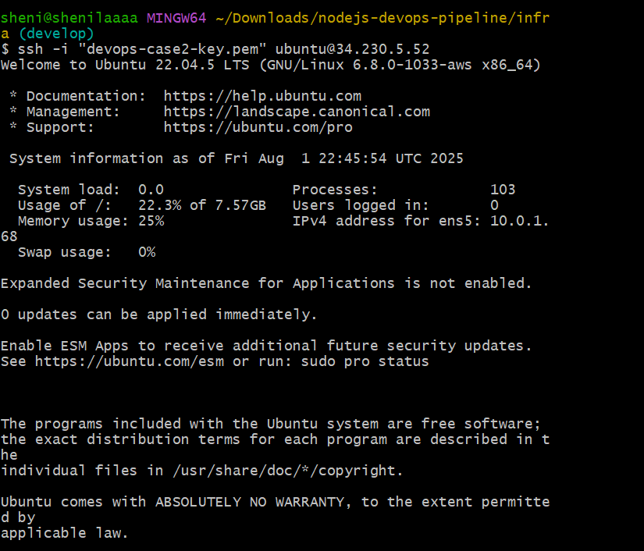

Server file creation and hosting 3000

Keep node app using pm2

Auto start on server reboot

Install Ansible on ec2 server

Run the Playbook

Jenkins deployment

Jenkins Job Creation

Jenkins console output

Shell Scripting and Cleaning

Pushing to Github

